CAA AFTER SCHOOL PROGRAM FAMILY CONTRACT

This contract is made effective as of ____________ by and between the following parties:

“Provider” Croton Academy of Arts (CAA)
8 Old Post Road South, Croton on Hudson, New York 10520
afterschool@crotonacademy.org , (914) 862-0988 \ and

Name: _____________Relationship to child:: ______________

Home Address: ______________City:_Croton on Hudson__ NY Zip _______

Place of Employment: ___________________work number: ___________________

Home Phone Number: ______________________ Cell Phone Number: _____

E-mail: ______________________

To provide care for: Child’s Name: ______________________
(a separate contract and health form must be submitted for each child)

The Undersigned Caregiver(s) hereby gives CAA permission to care for the above child(ren) in accordance with this Contract. In consideration of the mutual agreements and covenants contained in the Contract, the parties agree to the following:

1. CONTRACTED DAYS The Provider shall provide child care services and the Parent/Guardian shall pay for such services as follows:

❑ Monday ❑ Tuesday ❑ Wednesday ❑ Thursday ❑ Friday
This schedule will be in effect unless terminated sooner by either party in accordance with this Contract.
The Parent/Guardian shall pay child fees for the CAA After School program based on the above schedule at the rates specified below. Fees will not be adjusted for late arrival, early pickup, or missed days, except as provided by the Contract. There will be no refunds.

2. PROGRAM SCHEDULE

CET 2:30-6:00 pm (grades K-3) 6:30 for late pick up | PVC 3:00-6:00 pm (grades 4-7)

By signing this Contract, the undersigned represents that they understood and agreed to the terms and conditions of this Contract. Breach of this Contract in any way by the Parent/Guardian may result in immediate termination of services.

Parent/Guardian _________________________________

I hereby release the Directors and all employees of Croton Academy of Arts from all claims of liability for any damage or injuries which may be sustained by my child in the After School program or any class at the CHUFSD.

parent/guardian signature ____________________________________________

I hereby give permission for my child’s photograph to be used for program purposes.

parent/guardian signature ________________________________________

Pick up Authorization/ Emergency contact form

CHILD’S NAME ______________________________ ____

AUTHORITY TO PICK UP CHILD The following person(s) has authority to pick up the child(ren)

Name: ___________________________________ Cell number: _____________

Name: ______________________________ Cell number: _________________

Name: __________________________ Cell number: ___________________

The Parent/Guardian shall inform Croton Academy in advance if someone other than the Parent/Guardian or person(s) listed above will pick up the children.

DOES NOT HAVE AUTHORITY TO PICK UP CHILD
The following person(s) does not have authority to pick up the child(ren).

Name: ______________________________________________________________

EMERGENCY CONTACTS In case of emergency, Croton Academy of Arts will first try to reach the Parent/Guardian. CAA will need at least one of the three emergency contacts listed to be local to Croton on Hudson.

1.Name: ___________________________Relationship: ____________
Address: _________________________________________________
City: ____________________________ State: _____ Zip: ________
Cell Number: ______Ok to text _____ Other phone Number: ____________________

2.Name: _____________________________Relationship: __________
Address: _______________________________________________
City: ____________________________________________ State: ____ Zip: ___________
Cell Number: ___________Ok to text _______ Other phone Number: ____________________

3.Name: _________________Relationship: _________________
Address: ______________________________________________________________
City: ______________________________ State: NY____ Zip: ______
Cell Number: _____________Ok to text ______ Other phone Number: ____________________
Croton Academy of Arts is a 501(c) (3) not for profit corporation
CAA Health Information Form
A student of the Croton Academy After School Program student will not be
permitted to attend the program unless this form is completed and returned.

Name _________________________________________________________________________________
Last First Middle
Birth Date ___________ Gender Pronouns they/them ___ she/her__he- he/his___ Age__
Parent/Guardian __________________________________________________________
Child’s Home Address _______________________________________

Home Phone ( ) ________________________ Cell Phone _________________
Medications child is currently taking. (please be specific):
The CAA After School Program does not have the authority to administer prescription medications.

Allergies / Food Intolerances __________________ ___________________________

Check boxes to indicate if your child has any special needs/services: ❑ None

❑ Early Intervention/Special education ❑ Occupational Therapy

❑ Speech/Language ❑ Physical Therapy

Croton Academy is authorized to provide the physician or their office with the following medical information:

Hospital Preference (if possible): ______________________________________________________
Medical insurance carrier:____________________________ Policy Number: _____________________
Name of Policy Holder: ___________________________________________________________
AGREEMENTS
I consent to emergency medical treatment for my child ❑ Yes ❑ No
I understand the program may need additional permissions for situations such as ❑ Yes ❑ No
transportation or release of information.
I provided information on my child’s special needs to assist in caring for my child ❑ Yes ❑ No
I understand the program must give parents, at the time of enrollment of a child,
a written policy statement as required by regulation. (CAA Family Handbook) ❑ Yes ❑ No

I agree to review/ update this information when a change occurs and at least once yearly. ❑ Yes ❑ No

IMPORTANT: Please notify the CAA Staff if student is exposed to any communicable disease.

PARENT/GUARDIAN AUTHORIZATION

Signature______________________________________________ Date___________

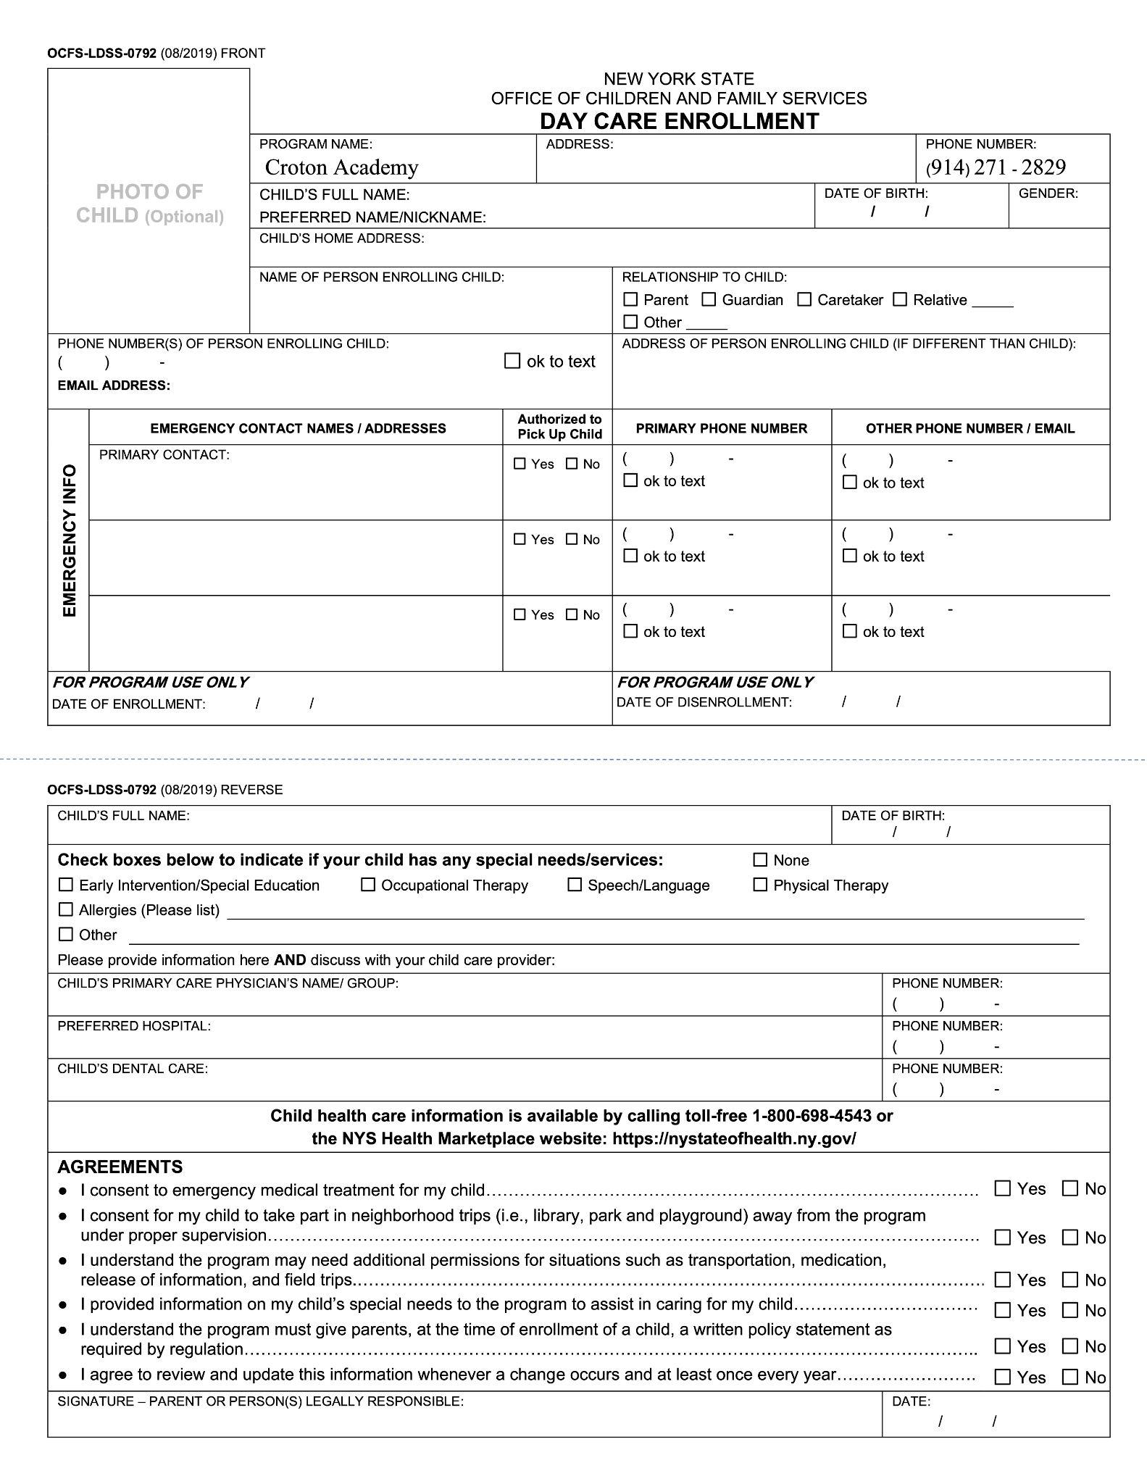

PROGRAM SPECIFICS

CET ARRIVAL AT AFTER SCHOOL PROGRAM: Kindergarten students will be brought directly to our program by one of our teachers from September through January. Other students are released from their classes to walk to the Multi Purpose Room.. Pick up is 6:00 pm unless late pick-up is pre-arranged and paid for in advance.

Parents/guardians will pick up their children at the back door near the multi-purpose room. Parents will sign their children out at the doorway entrance. If parents have questions or concerns please contact the program Director, assistant Director or Site Supervisor.

CAA staff cannot release children to any person other than those listed on our Pick Up Authorization form.

PVC ARRIVAL AT AFTER SCHOOL PROGRAM: students are released from their classes to walk to the Cafeteria. Our program must be notified in advance whether a student will be attending an activity, and students will be directed back to the After-School Center when the activity is finished.

CAA staff cannot release a child to any person other than those listed in our parent/guardian contract. Parents must sign their children out at the PVC side door. PVC students may walk home with written parent/guardian permission.

3. TUITION AT CET/PVC / PAYMENT METHOD / SCHEDULE CHANGES
Tuition charged is based on a 10 month school year and divided into 10 monthly payments. It is not specific to individual days or sessions for which your child is registered for that month. Early dismissals, snow days, sick days and personal absences do not reduce monthly tuition charges and cannot be substituted or refunded.

1. After the first month’s charge, future charges will be processed on the 20th of each month, for the next month’s attendance, through the Croton Academy of Arts website. Credit card information must be kept on file through PayPal. We cannot accept American Express cards for monthly tuition payments. Our families Inbox will receive an automatic email notification prior to each month’s charge on the 10th of each month.
2. Families must notify the After School program in writing to decrease or add days, dependent on availability, by the 15th of each month for the next month. There will be no charge for schedule changes if they occur before the next months tuition is charged. Families must also notify the classroom teacher in writing of the change.
If a change is requested after the tuition has been charged, a $30 processing fee will be charged.

Monthly Tuition rates:

 | 1 Child | 2 Children | 3 Children
2 days / week | $ 320 | $ 565 | $ 745
3 days / week | $ 425 | $ 745 | $ 980
4 days / week | $ 495 | $ 870 | $ 1150
5 days / week | $ 545 | $ 960 | $ 1265

Please contact Croton Academy of Arts if you plan to send two or more children on different days of the month. We would need to create a custom tuition payment schedule.

4. TUITION FOR DROP IN PROGRAM CET/PVC
The CAA drop in program is available on an emergency / as needed basis, to families currently enrolled in the after school program. The fee is $45 per day on days when participation will not cause the program to exceed student/staff ratio guidelines.

5. REQUIRED FORMS
In order to secure a child’s spot in the program, families must register online and submit the Contract, Pick Up Authorization/Emergency Contact, CAA Health Information and NYS Day Care enrollment forms
All forms must be completed in their entirety, signed and submitted before the child attends the program,

POLICIES AND PROCEDURES
Absences: It is the responsibility of each family to notify CAA and the school, in the event that the child will not be attending their program as scheduled due to illness, vacation, play dates, game day, etc. Please be aware that every precaution is taken by our staff to ensure each child’s safety.

Failure to notify CAA staff and the Main Office at CET/PVC of an absence causes unnecessary alarm.

Calendar: CAA programs will adhere to the same calendar as the Croton-Harmon School District.

Early dismissals and school closures: The program will follow Croton-Harmon’s weather-related or other early dismissals. Early dismissals for weather or other school scheduled days will alter the pickup times. For emergency dismissals we will attempt to close later than the school’s dismissal time to allow families to pick up. Each family should have at least two emergency contact numbers, including one that is local, for pick up.

CAA and the CHUFSD will have procedures in place to inform school district families of emergency procedures.
CAA After school care is not open on half days, early dismissal days or for Parent/Teacher Conferences.

Child Abuse and Maltreatment: CAA staff will report any suspicion of child abuse or maltreatment, following the guidelines of Mandated Reporter training. Reports will be submitted when CAA staff has reasonable cause to suspect that a child whom they see in their professional capacity is abused or maltreated.

Conferences/Concerns: Should any issues or concerns arise, a CAA staff member will contact each family and a CAA Director to discuss the situation. Conferences may be requested at any time by the family, or by CAA staff as needed. CAA encourages prompt and direct resolution of parent/guardian concerns.

Behavior guidelines: The children’s safety is our priority. Our goal is to provide a safe, supportive environment where each child may grow and develop. This means that we must hold our children accountable for their actions by teaching personal responsibility. Hitting, kicking, bullying and other harmful behaviors are unacceptable and will be dealt with on an individual basis.

Discipline issues should be directed to the Assistant Director.
- First offense: Quiet time, speak with Asst. Director. Provide a small break to reassess and reconnect.
- Second offense: A mandatory discipline report must be written and shared with the family. This consists of an explanation of action and consequence signed by the student, parent and After School Program Director.
- Third offense: The child will be sent home and may be suspended depending on severity of offense.

In circumstances where there is a serious act of violence toward another child or adult in the program, the family will be notified immediately and the student may be suspended or asked to leave the program.

Withdrawal requested: Our program may not be appropriate for a particular child or parent. The Directors reserve the right to ask that a child be withdrawn from CAA. If a child is asked to withdraw, tuition payments will cease immediately and any advance tuition payments will be refunded.

Parent/Guardian/Family Participation: We welcome parents/guardians and student volunteers to take an active role in this unique after school program. We encourage any family member with a special talent to make arrangements for a drop-in activity and we welcome the participation of our families in various aspects of our program: assisting in a holiday craft, outdoor game, etc. Please notify the program Director if you would like to volunteer and bring your talent or time to our program. Families are also invited to submit any ideas about how to improve the program.

